**Table of Contents**

* Letter to the Union
* [Survey Results of Google Usage](https://docs.google.com/document/d/1CESM4obY7Bdrh3iVpVD2gl3HWbmzf6xPZVrEYXKkbWE/edit#bookmark=id.8m2pfpz38p0w)
* [Meeting notes with district IT (Nov 2nd)](https://docs.google.com/document/d/1CESM4obY7Bdrh3iVpVD2gl3HWbmzf6xPZVrEYXKkbWE/edit#bookmark=id.u2bniynvmid1)

**Letter to LCS Union:**

Dear fellow teachers and Rocky Hannah,

Some basic features of the internet are going to be blocked starting next year in LCS.

The district's stance is that to protect our students we must block high-risk sites and cloud services such as Google drive, and Dropbox.  They were ranked above a threshold and will be blocked from access on June 1, 2022.  While other sites like Apple-iCloud, Facebook, and Youtube will not.  The ultimate decision is the superintendent’s. We hope you feel this is an important topic and you will take time to provide input on and support LCTA’s efforts to ensure the inclusion of instructional staff in decisions regarding the needs of our students and classrooms

For further information please feel free to contact JaSun at the following email address: [jasun.burdick@gmail.com](mailto:jasun.burdick@gmail.com)

**Survey of google usage in education in LCS schools**

* Survey sent to LCS students, parents, and concerned citizens
  + 189 people responded as of Nov 6th, 2021
  + [Take Survey Here](https://docs.google.com/forms/d/e/1FAIpQLSdMBwBr93Q5Y2erJbhBEU71xeDYwtTWhrNWZRv4KKBbuVeqYg/viewform) - Please submit and share

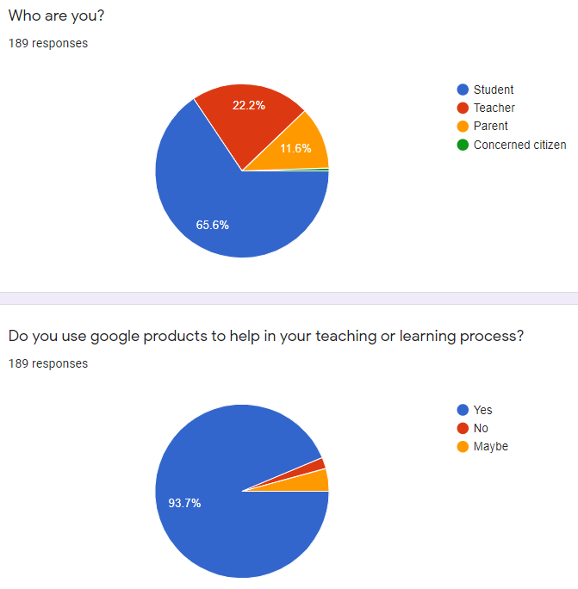

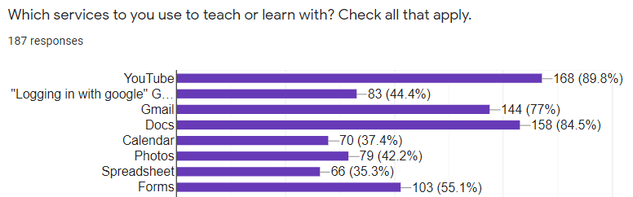

|  |
| --- |
| This will be extremely disruptive and detrimental to my students' learning. There is no reason to block these services. |
| Our student programs like journalism, the school newspaper, and SGA cannot have a school-based email. We use gmail and the G-Suite to run those educational programs and empower those students to have a vested ownership of the programs. Using Google also builds and facilitates outside student participation with those programs. Without Google access, the school newspaper (and journalism as a whole) shifts from being a school-wide interactive, participatory voice of the students to being just a classroom assignment. |
| I believe that this hamstrings the ability for students have versatility and flexibility in their academic pursuits. Google provides an array of platforms that students have relied on and utilized successfully for years, and taking away access to those platforms creates a roadblock to their success. For teachers, it dramatically limits the way they can present information and create curricular content. The less tools we all have at our disposal, the larger the detriment to the success of both teachers and students. |
| This is creating an unnecessary burden and obstacle for our teachers and students in a world that has required online learning and capabilities. Many students know and understand google and forcing them to a new platform has created confusion and often reinforced poor performance in the classroom. As an art teacher, youtube and photos are extremely important and this would essentially eliminate most of my student's resources. I also have had extra work added to my own already heavy load due to much of my curriculum existing in google already. This move robs students of resources and accessibility. It undermines learning across the board. |
| Google's resources are extremely useful for both teachers and students. Many of Google's services, such as Google Docs and Gmail, are better than similar resources from other companies, and some, like YouTube and Drive, don't have a good alternative at all. If Drive is blocked, so much work that has been stored on there will either have to be painstakingly transferred somewhere else or be lost forever. Docs is so much easier to use than Word, and being able to work with multiple people on the same Doc is a huge help. It would be ridiculous to block the entirety of YouTube, since the vast majority of videos used in teaching are only found on YouTube. There's no good reason to block all of these resources for everyone, and without them we'll be greatly set back in learning and teaching. |
| You are taking away websites with educational information, you are taking away websites with tools for teachers to use to help educate us because it's google yet we students gotta use CHROMEbooks. This logic makes no sense. Please reconsider. |
| Google is crucial to the way we learn. Having a free way to complete essays, do research, send emails, etc is very important. |
| I personally already have problems with them not allowing me access to my Gmail account, the proposed ban is ridiculous. every one person in this school uses google or a google product every single day. |
| I enjoy having as many viable educational options for students as possible. It makes sense to increase access to useful resources than to limit them. |
| These websites are very good recourses for learning and we can’t learn as well without them |
| Microsoft Forms don't have the same capability as Google Forms. Cutting off access to Google products will severely impact the resources I use in class. YouTube would be a huge loss as I incorporate videos often into my lessons. |
| It will take me a long time to convert these things to a different format which will reduce the time and mount of students able to access these materials. Some of these materials can not be converted and the students will lose access to valuable resources permanently. |
| There are almost always alternatives to the services google offers, but Google is the industry standard, it takes time to migrate content, let alone learn the ins and outs of new programs. That annoyance is multiplied across all the teachers that will have to make the change, all the students that will have to learn new tools, and then the entire district.  And Google services are the most commonly used in the world, so why should we learn/teach something less standard? |
| I think it would very much hinder the progress of a lot of the schoolwork that I do, and the amount of time it takes to complete it would go up. i think it is unfair to deny students of resources that some of them may completely rely on for their education. |
| It would make my processes a lot slower, meaning that I would have less time to learn, and would have to rush things a lot more. |
| Google's services integrate really well with each other making it super easy and efficient to find your assignments and learning resources. |
| google is easier to use, and to work in. |
| Many students use Google for their documents and power point projects(Google Slides). Their Google accounts will not be terminated at the end of their public school education like their Microsoft accounts, which means they can keep all their work and files in the same place. Limiting accessibility to these programs will just lead to less digital literacy for our students. |
| It think it will be really bad if you remove these. I use these app all the time and I’ve found them really useful these pass years. |
| My student has an LCS Chromebook. The Chromebook won't recognize my printer or my scanner so he has to work on my laptop because he can't email his work to me for printing or scanning because it's an outside address. He can't put it on my Google drive either. He can't print assignments or scan in work to submit to the teacher. I put in a ticket to LCS tech support. No response. I called them and they just said "we are a Microsoft district".  In a corporate setting you would put administrative controls on the company provided machines. But then you would have an IT department to set up peoples' printers or help them install productivity software etc. LCS has done the first half and neglected the second half. It doesn't work. |
| This might end up making submitting work from different devices complicated or possibly impossible. |
| everything i do is on google |
| If google services is no longer allowed then I would have to learn a whole new interface just to be able to continue doing what I'm already more than comfortable doing!!!!!!!!! |
| I know a lot of teachers use google, such as google classroom in order to help them teach, and without that a lot of them can't teach the way they used to. Also a number of students use google docs, slides, and other online google things to help them with their schoolwork. |
| Many of my teachers use Google for my educational benefit. Therefore, blocking Google would severely decrease my education and learning ability at school. |
| I use google photos to turn in assignments on my computer that I have taken a picture of on my phone. |
| If they were to disable our use of Google services, many things would be so much more difficult to do. It wouldn’t be the end of the world, obviously. However, some people prefer to use docs over word, and getting rid of our use of docs would inconvenience many people, like myself, who prefer docs and have already been using it. Also, many teachers use YouTube in order to show videos that help further explain topics they’re teaching/relate to the topic. That would just inconvenience them. |
| It will impact the education process because its changing everything us students know how to do. Let me explain so basically we've been using things like (Google docs, Google classrooms, canvas, etc.) thats what we know how to use because that's what we've used all this time. to change that all up it would effect grades for some students and it might cause stress for some students who don't know how to use it. |
| It’s helps me learn better |
| It limits both teachers’ and students’ resources |
| It’s an unnecessary hurdle that I have to get around and I have to settle. |
| I, personally, use all Google services to work on projects and write essays (Docs, Slides, etc.). It's super easy for me to access these assignments from anywhere and on any device. If I need to have a specific file on a specific device, I just sign into my Google account and email myself the files. Removing the Google Cloud services would be a detrimental mistake. |
| For me, it would make it more difficult to find credible scholarly articles. Research is very important in quite a few of my classes. |
| Losing Google access would be a serious hardship to the education of my children and the ease with which we are able to access information. |
| Not being able to use the Google cloud will make it more difficult for students to save work and share it with their teachers for grading. |
| It will limit students resources and also make using the chrome books harder than necessary. They are built to work with google and not using google defeats the purpose |
| Jamboard is a Google exclusive brainstorming app that I use regularly for student engagement during the writing process |
| It's already started and it blocks my students and myself from doing what we need to get done. I'm a teacher and parent. |
| The loss will hurt my classroom lessons I teach media and need those connections |
| All of my questions of the day are on Slide Decks…I create MOST of my materials, Google is more user friendly than Microsoft. |
|  |
| I store most of my lesson materials on my Google drive because it is my intellectual property and anything we put on one drive is subject to LCS ownership.  Additionally the one drive is bulky, not user friendly, often lags or is unavailable.  GIVE US BACK GOOGLE! |
| I trust our teachers to make the best choices for teaching our students. I want to make their job as easy as possible. Please listen to them when they say this change would make their jobs unnecessarily difficult! |
| I will no longer be able to live update information for students and parents. My access to digital creation tools will be removed and I will no longer be able to produce engaging and rigorous instructional resources unless I work on my own time, which I am not paid for. |
| I use these tools to help students learn and access multimedia outlets and programs for video production. |
| Canvas is very compatible with google slides |
| It would block many services that myself and my students use daily. My students all utilize gmail and will undoubtedly continue to use it after graduating. |
| When my daughter does research through Google for papers how do you expect her to have multiple sources is you block the main search engine that provides the multiple sources? |
| it is much easier and more simple to use than Microsoft office and it is also easier to save documents on google docs than it is on word which is important from a student point of view |
| My child has been using Canvas since last fall. Her teachers have posted links to many support materials, assignments, and assessments that are in a format or in a location that is not Microsoft based.  Does this mean that all of those hours of teacher prep are going to be lost and have to be doubled so that they can put these documents in the preferred format?  Did you get feedback from parents, teachers, or students about their use of Google or other cloud services? |
| Google Chrome books are designed to work seamlessly with Google products. Google has a host of suites with limitless potential.  uploading videos to YouTube, Google docs, Google drive, all are universal and easy to use.  There are a host of Google products that offer additional education opportunities not currently being used. Programming, cyber security, app development, are all untapped entry points into high-demand pathways to careers. Making a unilateral decision to block Google products would drastically limit students' future potential. Also, Google is the industry standard platform. Our students would end up locked out of programs that almost every business professional uses. |
| I am not clear in understanding why the limitation of cloud services have been limited to Microsoft only. For heaven’s sake, we have Google Chromebooks for every student in the district! It can’t be a compatibility situation.  Please ask teachers how they would be impacted by this change before making a blanket change that has greater impacts than you might imagine.  I know of one teacher at my school how used Google docs on the majority of her online instruction during the quarantine time in Spring 202 and all last year. She is still using the resources she created, purchased, and/or copied links to for this year. When she learned of this change, she said that this will be her last year of teaching. She is a 6th year teacher who is tech savvy and dynamite.  Please don’t make us teach with one hand tied behind our backs. The impacts of this decision are far-reaching. |
| As a Media Specialist we use Google and all of its products daily. I can’t believe they would do this since we spent thousands for the Chrome books. I hope they they understand how big this impact will be. . |
| Make it unnecessarily difficult to access my files—my students already have this issue with their chrome books, and many prefer personal computers for this reason. |
| Inability to access commonly used educational resources, moving counter to the open movement of the education world at large |
| I maintain my resources on Google Drive and regularly use it to collaborate with other AP teachers across the country. Every AP training I have attended they use GDrive to give us resources. My academic team uses GDrive to collaborate.  Getting rid of these resources will disrupt so many procedures and operations of teachers. We already have so many obstacles in our way, please do not create more. |
| It will make it more difficult for me to do my job. I find Google services easy to use and it's free. There are enough obstacles in the classroom, why is another one being added to this? |
| Videos are one of the most useful tools to teach elementary level children. Removing this service would be crippling. |
| i wont have easy fast access to educational tools that i need. |

**Meeting with the district:  November 2nd 2021**

**Digital Cloud Services in Leon County Schools**

Jasun Burdick, Matt Roberson, Jessica Chapman

William Nimmons, Justin Williamson, Charles Daffin, Dale, Joiner, Deana McAllister

Rosanne Wood, Scott Mazur, (Not all names collected)

**Notes taken by Jasun.**

They are an incomplete record mainly just snapshots of the meeting questions and main ideas.

* Why are there these new policies?
  + Where is this coming from?  Who is making us do this?
    - Stoneman Douglas - State/Federal statute
      * FERPA
      * Structural Continuity Plan
    - DOE -
    - State Audit -
    - Risk Assessment
  + Are there any strict rules or are these things flexible?
    - About: What, when, who it affects,...
    - Nimmons recommended no Facebook (over ruled by Rocky)
  + Who at LCS is making this decision?
    - Is there a committee?
      * Nimmons makes recommendations
        + Rocky can accept or veto
  + How much infrastructure and costs have we invested in Microsoft?
    - How long is our contract?
    - Have we revisited this or will we ever?
      * Never and we won’t (later said after 3 years, retirement)
    - What is the cost per student for Microsoft + canvas?
      * Unknown
    - Google Workspace for Education Plus:
      * [$5/per student / year](https://edu.google.com/intl/ALL_us/products/workspace-for-education/editions/)
  + What is the specific risk(s) that cloud services expose?
* Cloud Services
  + How much are we going to block?
    - Personal File Sharing
    - Dropbox, box.com,
    - Block risk 5 and 4 levels
      * Palo Alto ranked it
  + Why did we select google and Dropbox and not other products?
    - Adobe,  Autodesk,  I-cloud,
  + Why do we allow Facebook and twitter and not educational products?
    - Rocky allowed it
* Transition Plan
  + Do we have to do this in the middle of the year?
    - How to notify, timelines, Leon Leads to check off acknowledgement
    - June 1st New Date
  + Are we ready?  What will this affect?
    - Will you look into google Sign in on other sites
  + Microsoft one drive available for 1 year after graduation
* LCTA - look into other districts only allowing one LMS

**District Policy on Data Security**

[**https://go.boarddocs.com/fla/leon/Board.nsf/goto?open&id=APTNZW5D2E14**](https://go.boarddocs.com/fla/leon/Board.nsf/goto?open&id=APTNZW5D2E14)

8305A - **INFORMATION SECURITY RESPONSIBILITIES**

The District collects and maintains large amounts of data/information that must be protected and preserved.

To strengthen security of District technology and information resources, the District has developed a series of information security policies and/or procedures available through the District’s website.

**Expectations for All Technology Users**

Users of District technology resources must understand and fulfill their responsibilities under the applicable policies.

1. Because confidential data exists in many forms (examples: written, electronically recorded, printed, etc.) users are responsible for insuring this data is properly secured at all times. This may take the form of physical security (examples: locked cabinets, locked doors, locked building) or through digital security (examples: password protection, encryption). All users with access to the District's confidential data must store confidential data in District approved storage locations unless the confidential data has been encrypted. The District approved storage locations are:  
   1. District network drives.
   2. Microsoft OneDrive.
2. All confidential data being transmitted must be encrypted. For example, a confidential file attached to an e-mail must be encrypted.